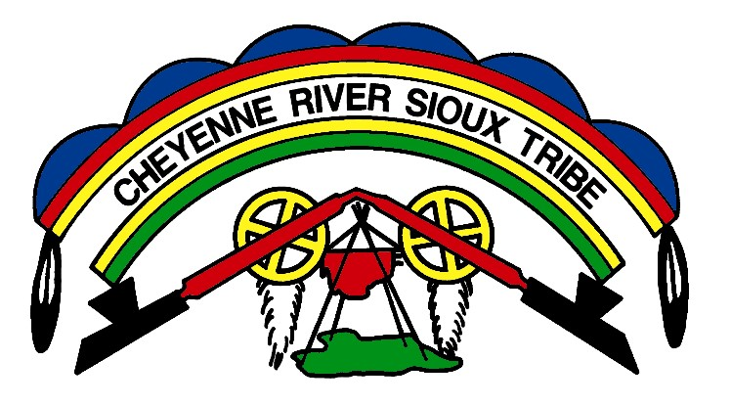

November 16, 2016
FOR IMMEDIATE RELEASE:
The following statement can be quoted whole or in part*

PRESS CONFERENCE STATEMENT BY CHEYENNE RIVER SIOUX TRIBE CHAIRMAN HAROLD FRAZIER REGARDING DAKOTA ACCESS PIPELINE

For nearly eight years, President Barack Obama’s Administration has taken unprecedented steps to mandate the education of federal land and management agency officials on the necessary steps the United States Government must take in order to honor their solemn duty to protect Native lands, our sacred places and to uphold treaty obligations to our people.

Last month, I had the great honor of sitting down face-to-face with President Barack Obama once again to relay the message that the Cheyenne River Sioux Tribe and the united voice of the Great Sioux Nation maintains its fervent opposition to the on going construction and planned completion of the Dakota Access Pipeline project (DAPL).

In recent days, I along with other Great Plains tribal leaders have met with officials of the Obama Administration, including agency officials from the Army Corps of Engineers, the Departments of Interior, Justice, and Transportation to urge the administration to withdraw the FONSI issued in June of 2016, and subject DAPL to a full Environmental Impact Statement (EIS).

DAPL proposes to send 570,000 barrels of oil each day under Lake Oahe. The Environmental Assessment and FONSI ignored the fact that this poison will flow beneath treaty-protected waters and will plow through sacred sites and treaty-protected lands. This water is the source of drinking water for several Native Nations in North and South Dakota – as well as dozens of non-Native communities downstream.

The July FONSI was based on a severely deficient Environmental Assessment, therefore it must be withdrawn. The United States has not yet conducted a full examination of the impacts of DAPL on the health of our people or environment. To date in 2016, more than two-dozen oil and gas pipelines have ruptured in the United States. More than three-dozen similar incidents occurred in 2015. It is not a matter if this pipeline will poison us, but when. The magnitude of negative effects that would potentially occur if such a spill were to take place along any part of the Dakota Access Pipeline would wreak unprecedented havoc on our entire environmental ecosystem. To ensure the protection of our people, our religion, culture, and the safe exercise of our treaty rights, denying the easement until an EIS can be generated is undoubtedly necessary before any further drilling continues.

In light of the constant threat that the Dakota Access Pipeline poses to our communities, I also ask that the Department of Justice continue to intervene to protect the peaceful exercise of our water protectors’ First Amendment rights. Dakota Access, LLC, and its parent corporation Energy Transfer Partners, has openly violated federal laws designed to protect our treaty rights and sacred sites. They have turned peaceful protests into violent confrontations.

Taking these steps to stop DAPL fully aligns with the Obama Administration’s strong policy positions, the December 2015 Interagency Memorandum of Understanding Regarding Protection of Indian Sacred Sites, Executive Order 13007 on Indian Sacred Sites, the Native American Graves Protection and Repatriation Act, and other federal laws designed to protect and preserve Native sacred places, religions and ways of life.

I urge President Obama once again to subject DAPL to a full Environmental Impact Statement and insist that the easement be denied until a full assessment of this project has been undertaken so as to protect our way of life. Protecting our sacred lands, waters, and treaty rights will cement your legacy as a President who truly advocated and fought, not just for Indian people, but for our Unci Maka—our Grandmother Earth who sustains us all.

